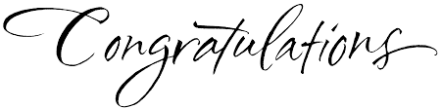
Your artwork has been selected to be displayed as part of the 4th Annual Greeley Youth Arts Month
Opening Night: Friday March 1st from 5-8pm

Downtown Location: ____________________________________

Be sure to stop by and see the all K-12 District show featuring “Music” artworks at the Academy of Natural Therapy at 631 8th Avenue in downtown Greeley. Walk around downtown to see other school’s artwork, enjoy dance performances, guitar players, singers, and so much more! It is a fantastic event, fun for the whole family.

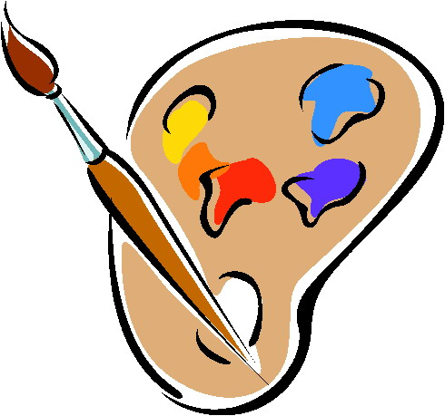
Student Artwork will remain on display for the entire month of March if you are unable to attend the opening night. View the website www.GreeleyYouthArt.com If you have any other questions. You can also view the event map on the website!

